**Requests must be submitted by SEPTEMBER 30, 2018**

1. Enter Site at the following Link: <http://www.gymjas.com/mo/meetdir.php>
   * You will land on the Meet Director’s Menu for Missouri page

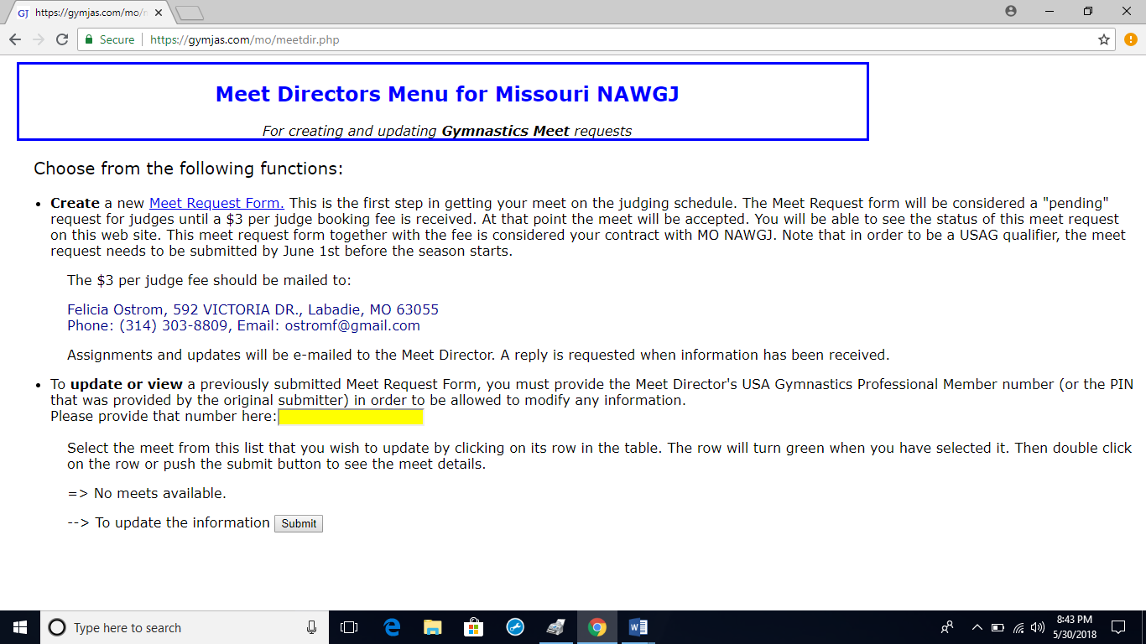

1. Click on the **Create** a new Meet Request Form, and start filling in the information for your competition



1. **Meet Name**: give us the name of your competition
2. Give us the **Start date** of your competition
3. **Expected length of the meet**:
   * 1 day (or partial day), 2 days, 3 days, 4 days
4. **Please indicate your date flexibility**: (NEW Feature)
   * This is for use if you have flexibility for assigning purposes:
     + Possible Meet Days: Saturday, Sunday (choose for 2-day meet)
     + Possible Meet Days: Friday, Saturday, Sunday (choose for 3-day meet)
     + Possible Meet Days: Friday, Saturday
     + This meet can only be held on: Friday, This meet can only be held on: Saturday, This meet can only be held on: Sunday 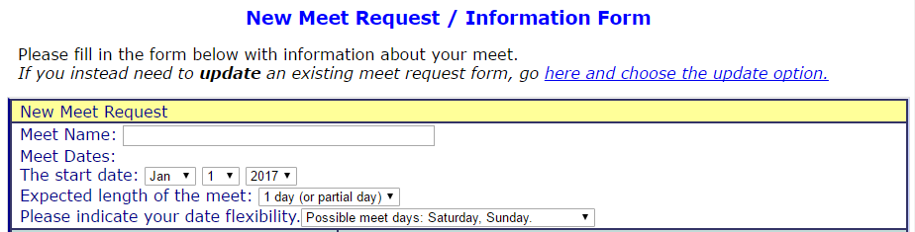

*\*If you believe there is any possibility your meet will extend to 3 days, please choose the Friday, Saturday, Sunday option. It is very difficult to extend the meet to Friday if it is not originally assigned as a Friday meet.*

1. **Gym Information**:
   * Find your gym in the drop-down, address will pre-populate below it
   * If it is not in the drop down, please enter your gym name in the box and enter your address below
2. **Contact information**:
   * Enter the Meet Director Information
     + Name
     + Best phone number *for the Assigner to be able to get in touch with you*
     + Email address *for the Assigner to be able to get in touch with you and for judges’ contracts to be received*
     + **Meet Director USAG number-** this is very important that you get this correct as it is your password to be able to enter the Meet again and update any info

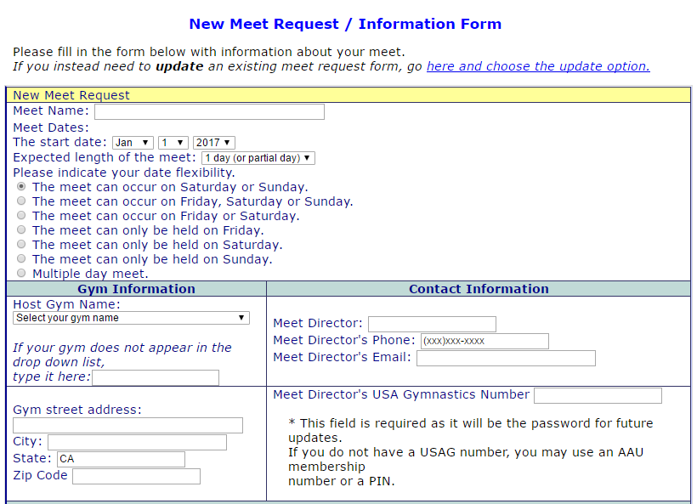

1. **Meet Details**
   * Meet Location-if you are using an outside facility please mark that choice and type in the name in the box, (we will gather the new address via emails from your assigner of your competition).
   * Number of Gymnasts
   * Type of Meet
   * Meet Format
     + Traditional format, Capital Cup, Modified Traditional (Warm-up Compete), Modified Capital Cup, Unknown at this time or Other
   * Levels: please list all levels and change as necessary
   * Entry Fees
   * Anticipated number of judges
     + List total per day – 8/16/24 judges/ day (1, 2 or 3 gyms-optional season)
     + List the panel configuration: 1 or 2 judge panels
   * Meet Referee
     + Either a judging MR
     + Or Separate MR (Usually for large optional competitions)
   * Uniform?
     + If you are having a themed meet and would like the judges to accessorize for it, please change this from Official
   * Judges’ Fee Structure
     + USAG (only choice for USAG Sanctioned competitions)
   * **Comments for the Assigner** (if you need to let the assigner know any special circumstances about your meet; i.e. you have a list of preferred or non-preferred judges)
   * **Click here** to let the Assignor know you have more comments to let them know about that won’t fit on the 150 characters above (at this point we don’t know who your assigner will be some this check mark ✓ will prompt them to ask you about additional info you want to give to them)
     + List preferred judges (not guaranteed depending on their availability)
     + If you are having a multiple 2 or 3-day Optional Invite and know the Level structure of the days, please list that info here. For example: (Fri. Level 3-5, Sat Level 6-10, Sun All Xcel)
   * Terms and conditions- Check the box and answer the security question
   * **Submit** your Competition Request
2. Enter more competition(s) (if applicable) and Pay!
3. Your competition(s) will remain in a **PENDING state**, and will not be in the queue to be assigned until full payment of Judges Fees are received.
4. If you need to **adjust/ update information**, provide the MD USAG number(password) and double-click on your competition below, please always go back to the form and update and please also **let your assignor know about your updates.**
5. **Paying your Fees**: ($3 per judge requested)



* + Pay by credit card through PayPayl at the following link: http://monawgj.org/id15.html
  + Or make checks payable to ***NAWGJ-MO*** and mail to: Felicia Ostrom 592 Victoria Dr Labadie, MO 63055

***Thank you!***